оригинал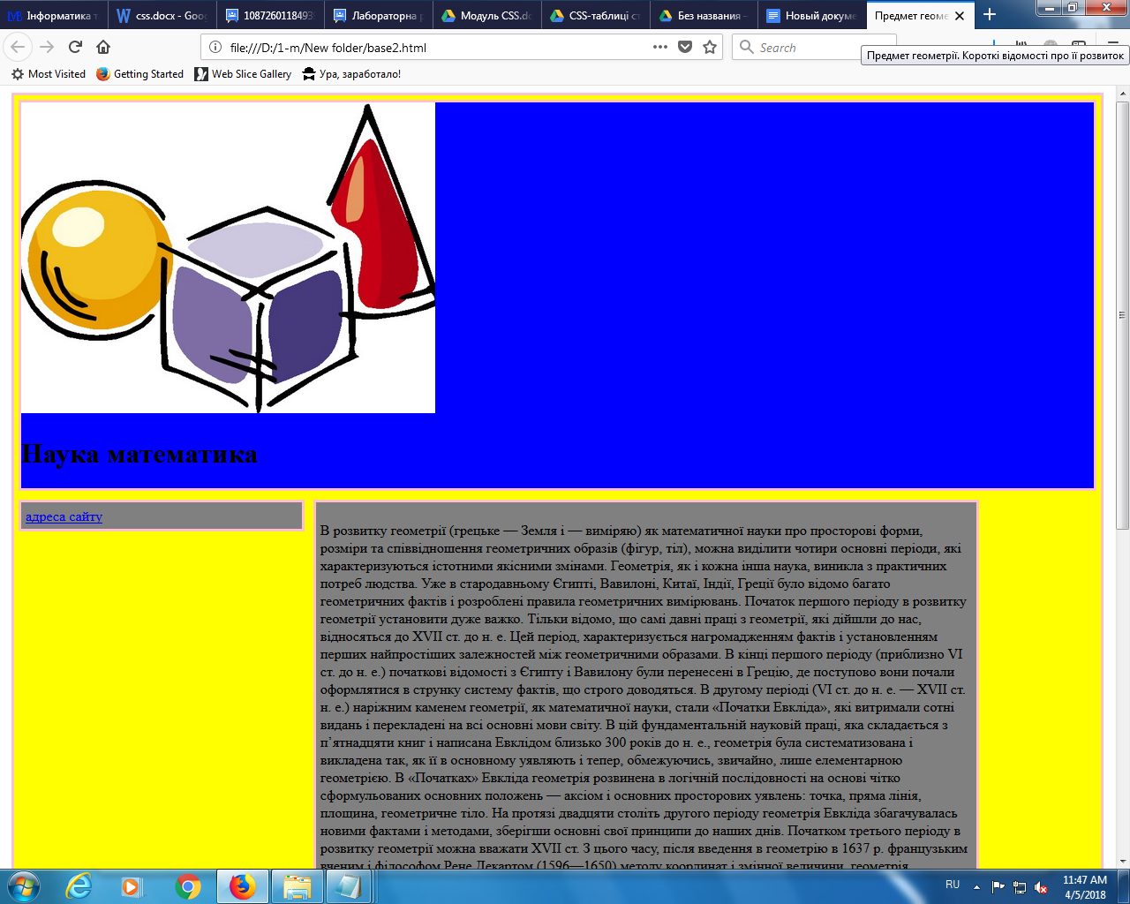

font: bold 14pt Times New Roman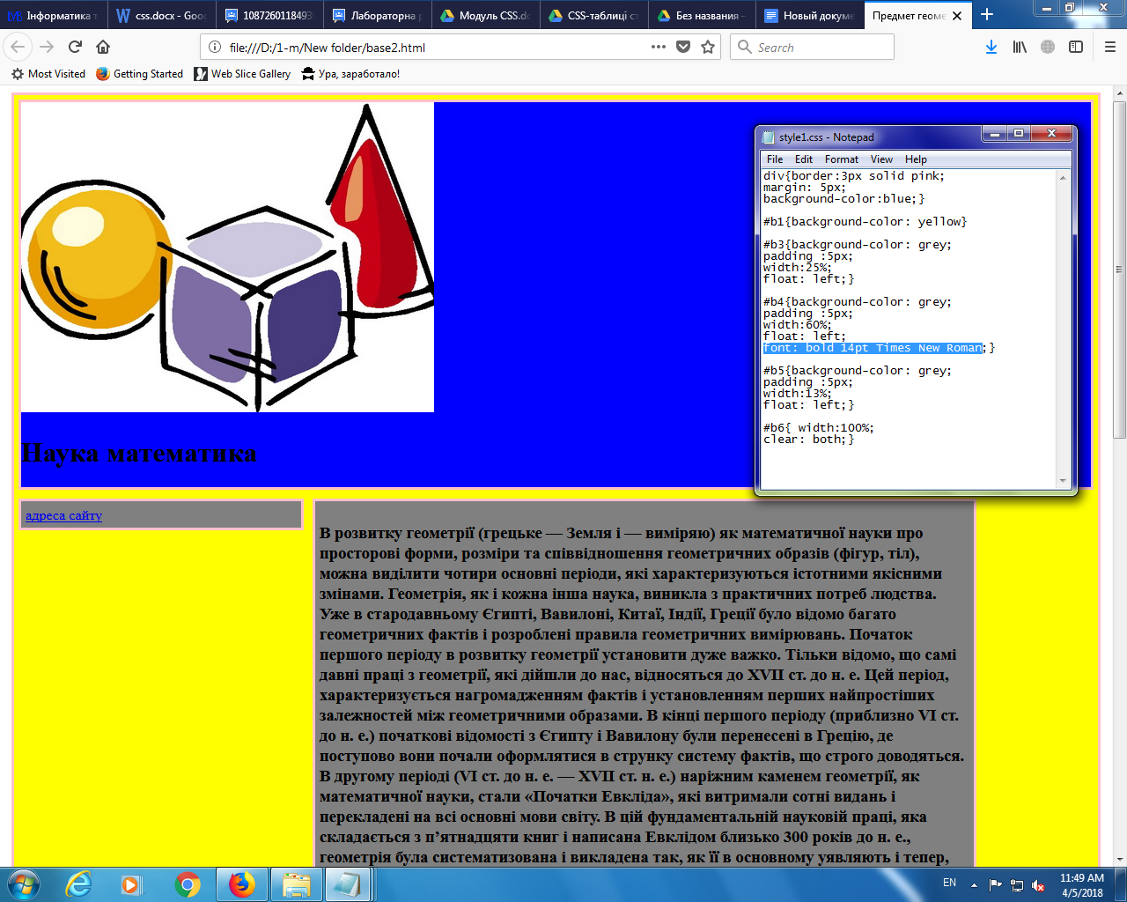

font-family: Helvetica,sans-serif;

font-style: oblique;

font-size: 15pt;

font-variant: small-caps;

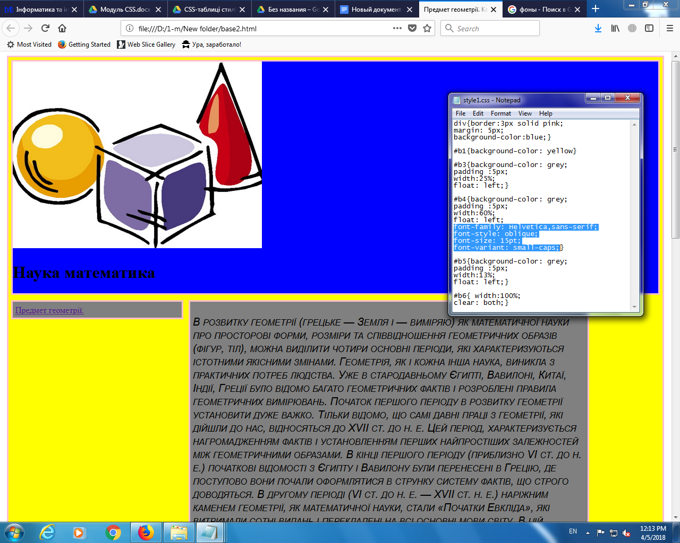

background-image: url(<https://avatanplus.com/files/resources/mid/58fa0cd9cb04815b90c232e8.jpg>)